Aston Arrows Update December 2022
This term has been very busy for Aston Arrows. We have continued to build the car framework whilst fundraising for much needed equipment and resources. We have also had some weeks where we have taken a break from the car in order to learn about one element of science and technology related to the car.
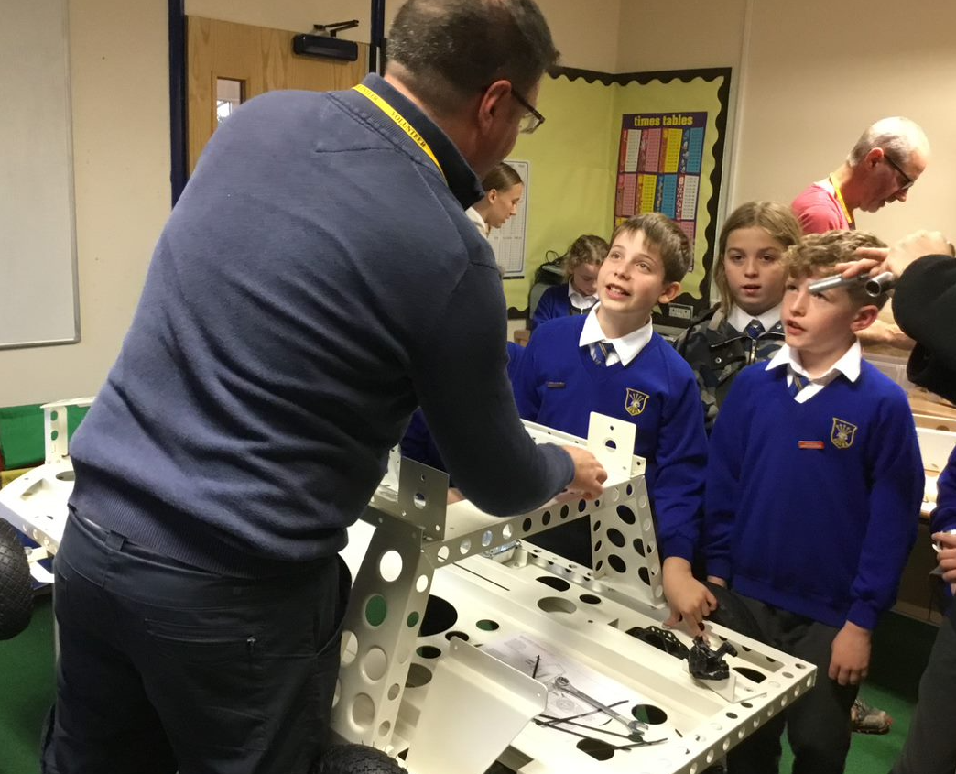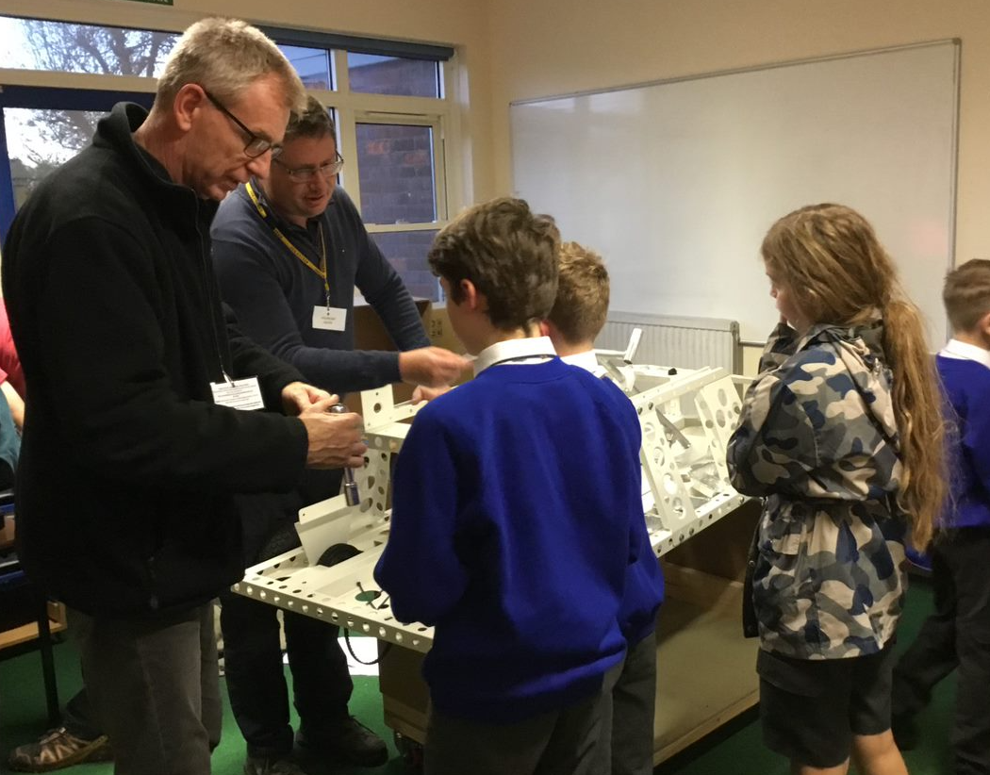
Our fundraising team have been working very hard sending out letters to local companies for sponsorship. They were thrilled when they received an email from our local engineering company, De Souter, with an offer of funding to help our project. We are so grateful to them for showing interest in what we are doing, and we are hoping to show them exactly what we have achieved next term.
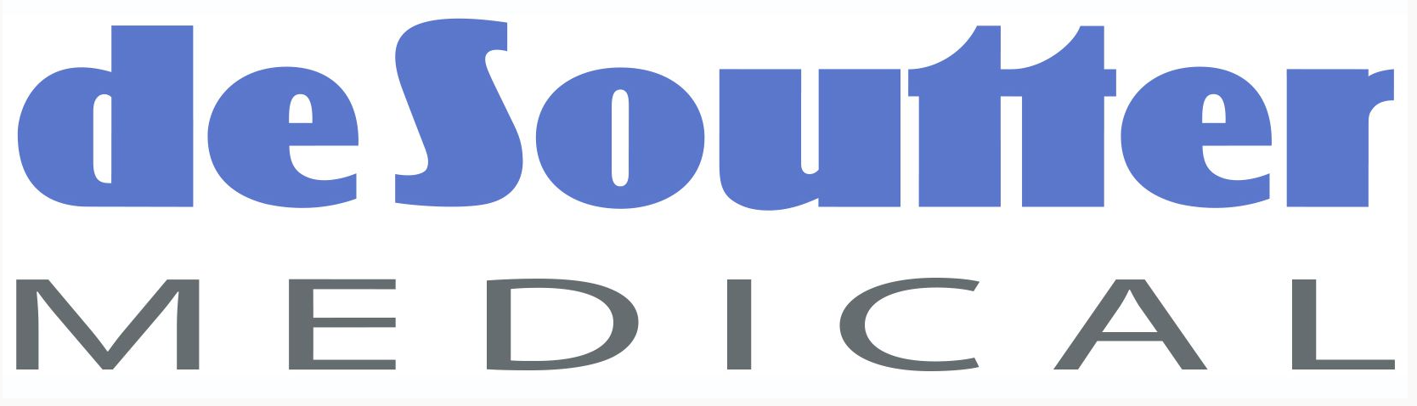

The fundraising team expanded in November to plan activities to raise money and awareness of our project at the school Christmas Fair. They came up with some wonderful ideas and in the end we occupied a whole classroom and the corridor outside, making over £250 on the day! This also gave the children a great opportunity to tell the community about the project.
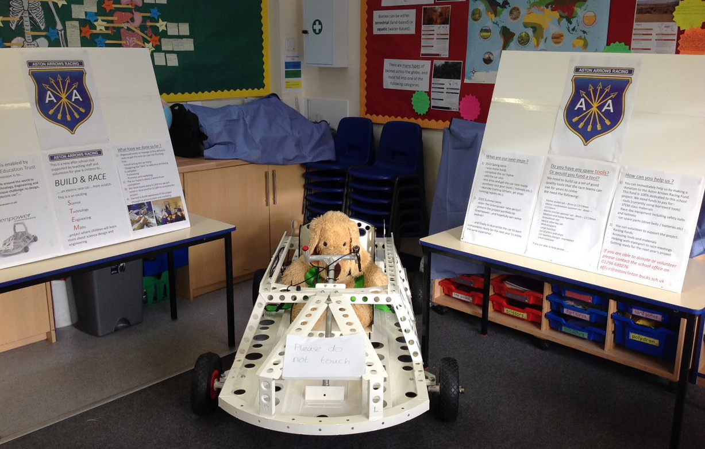

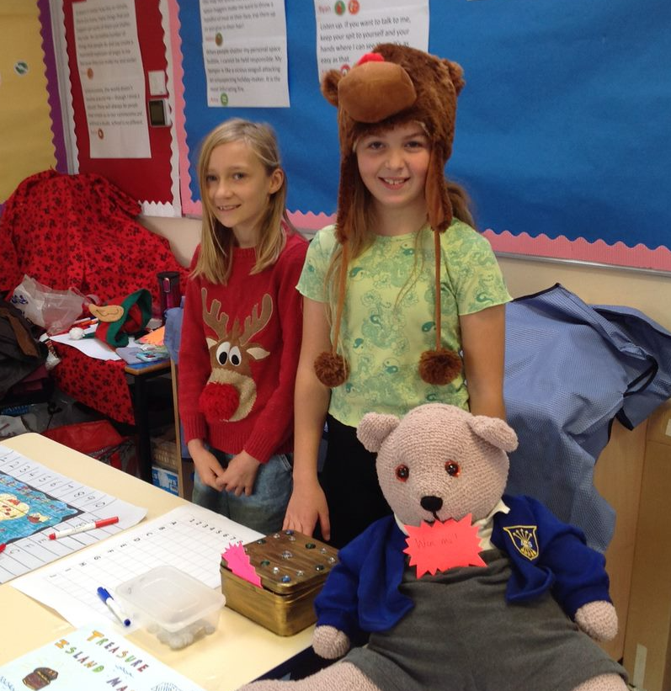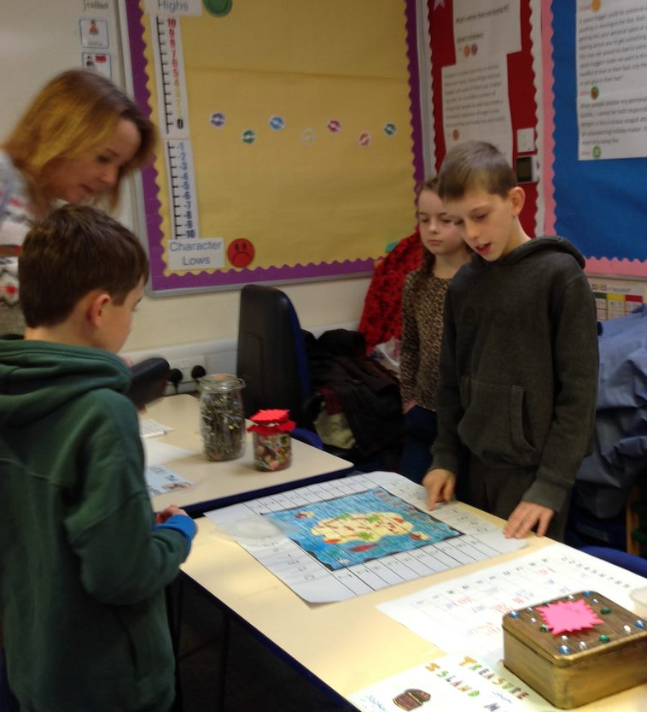

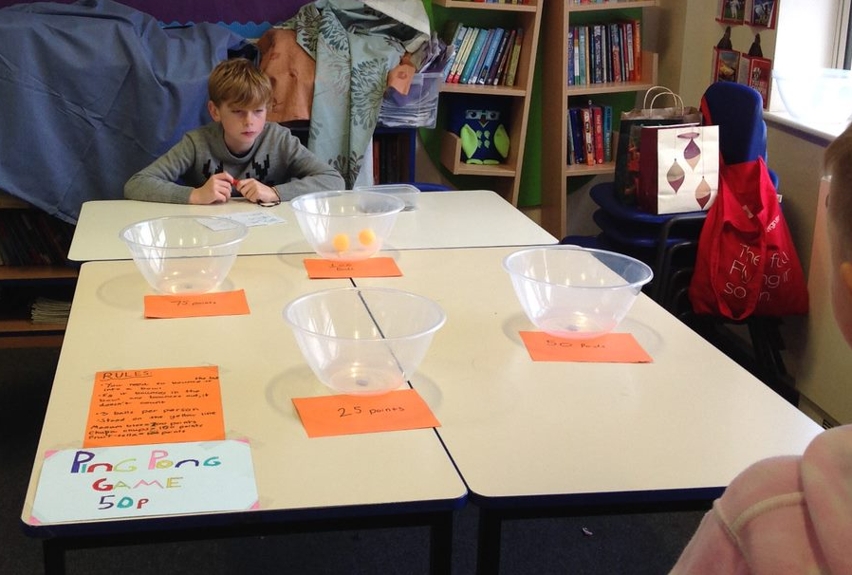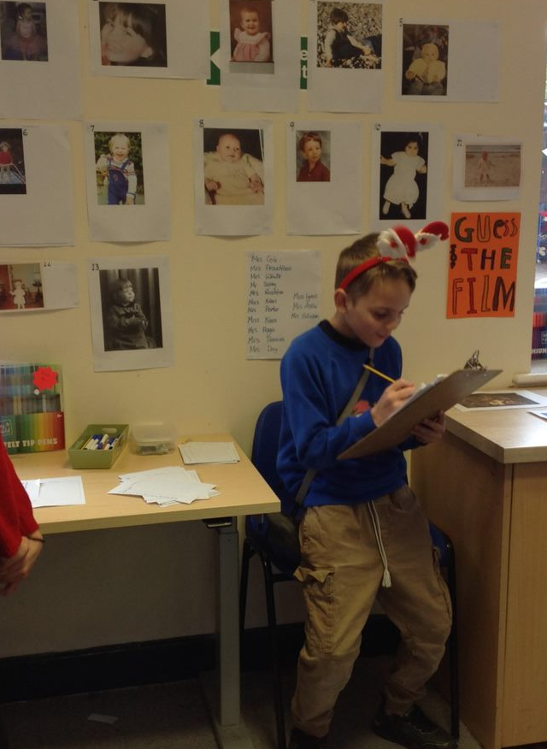

STEM activities
We had a pause from the building and fundraising to explore how electromagnets are made. Andy explained the difference between permanent and temporary magnets, how electromagnets worked and demonstrated making one from wire, a large nail and a battery. Then the children worked in groups to create their own and test the magnetic force. They even found out that the nail remained magnetic for a while after the battery was removed! Andy blew their minds by showing how a baked bean can is magnetised if it sits in a cupboard for a long time!

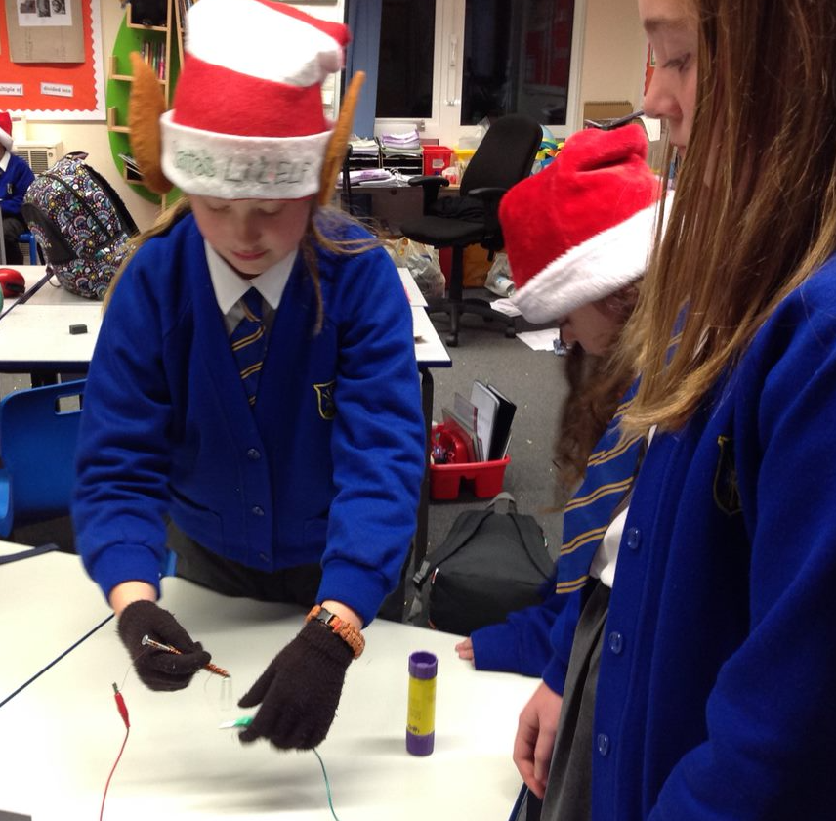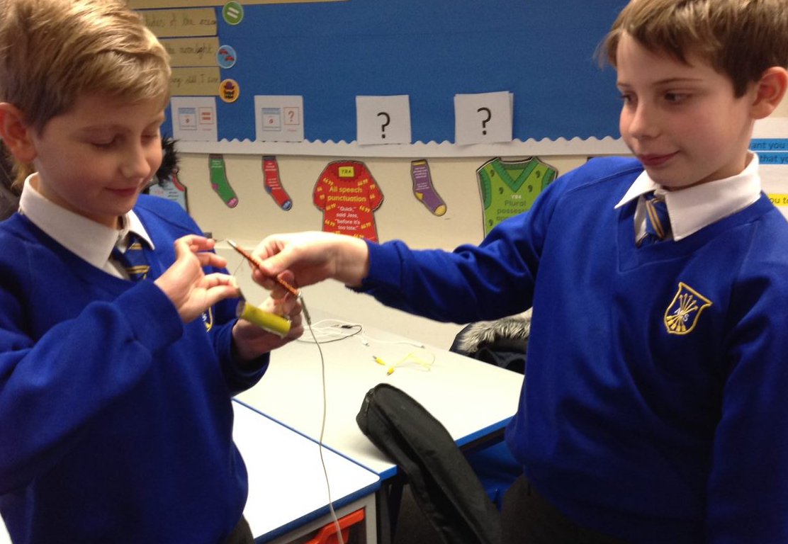

On our final meeting before Christmas, we challenged the children to make the tallest tower that could support a using only paper and tape. It certainly tested their knowledge of strengthening structures!

Aston Arrows Update January 2023
Our club feels fully established now and we are making great progress. We have had another expert join us from our local community, which has meant that the building of the car framework is almost complete. The teams are becoming more fluid so everyone who wanted to build part of the framework has had a chance. We have made some mistakes, but this is part of our learning curve!
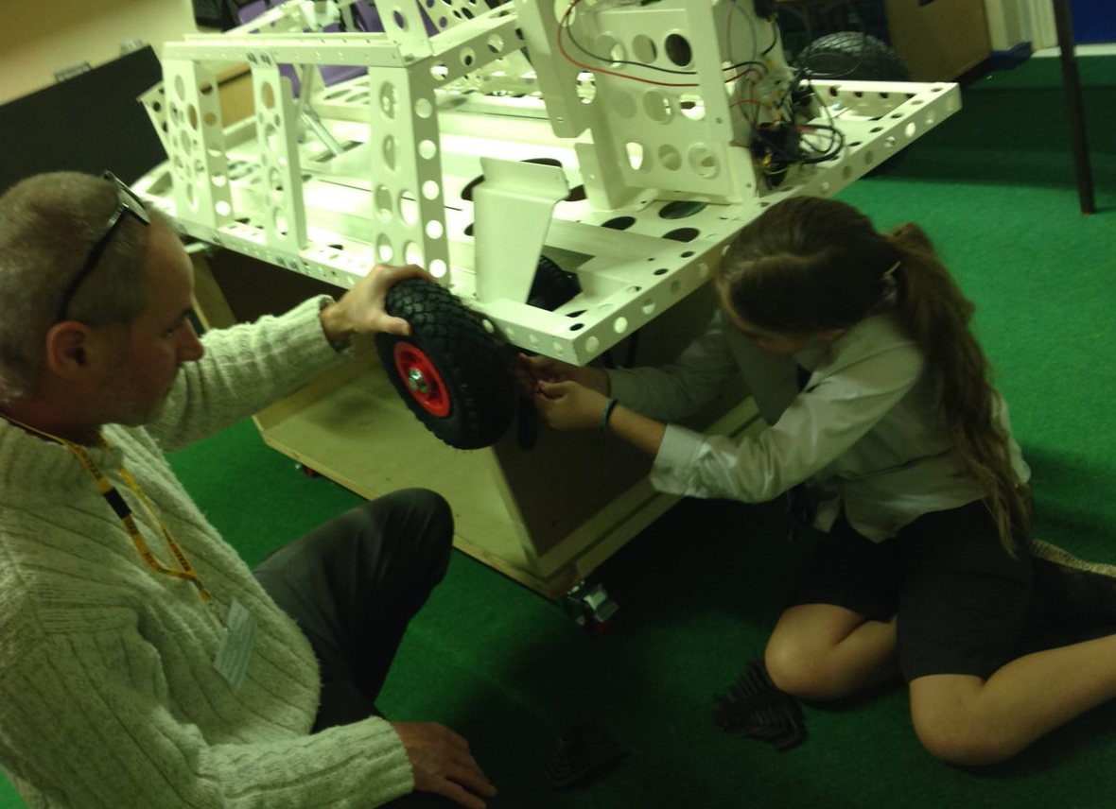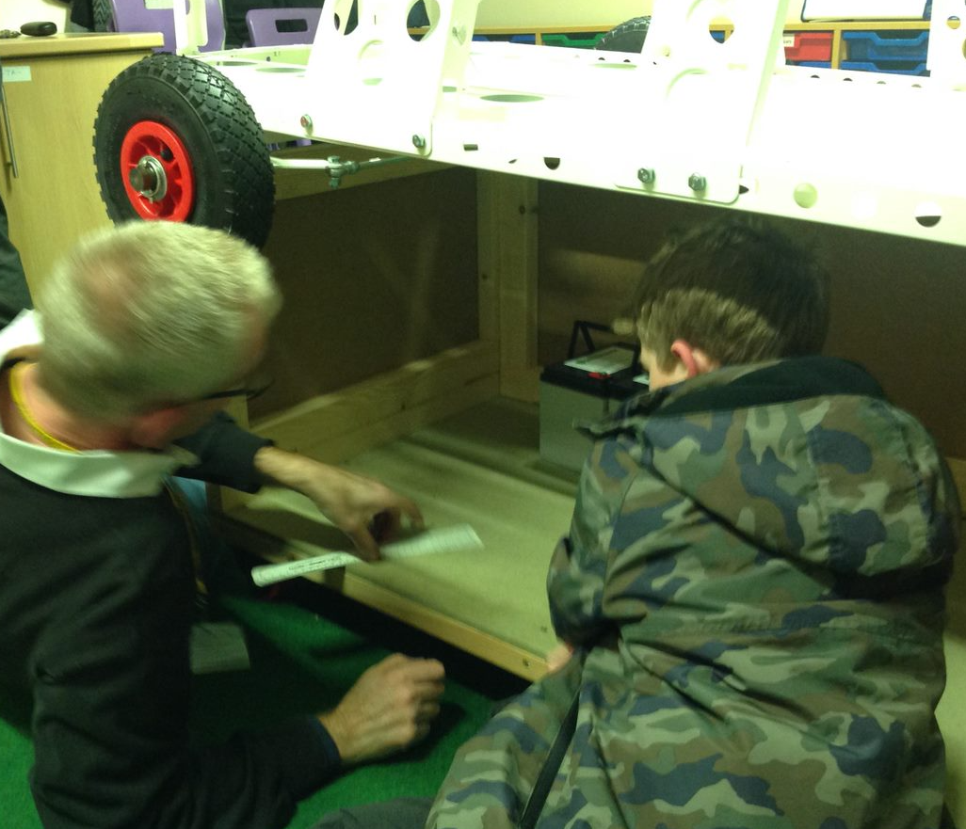

We are now turning our focus onto the bodywork design. As with any project like this, we cannot afford to make up a full- sized prototype of every bodywork idea the children have so we are making models to share idea and will decide on the final design as a team.



