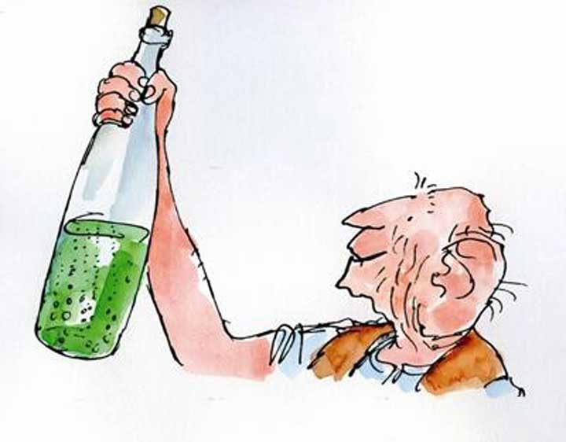
Hello everyone and welcome to Year 2! Our class name for Year 2 is Whizzpoppers inspired from the book ‘The BFG’.
Welcome to Year 2

We are so excited to get to know you all and have a brilliant year together.
Miss Herson

Key adults in Year 2


Mrs Clark

Miss Wilmot

Next Year
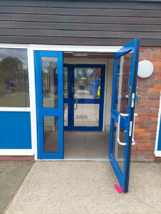
Luckily there are lots of things you already know a lot about. You will come into school in the morning through the same gate on the playground and door as year 1 and then walk round to our classroom.

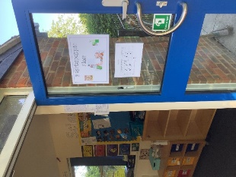
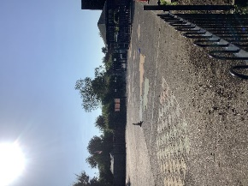
At the end of the day you will leave with your adult off of the playground through the gate. This is just like you did in Year 1.

This is the outside door for our classroom which you will come through after morning break, lunch, and leave through at the end of the day.

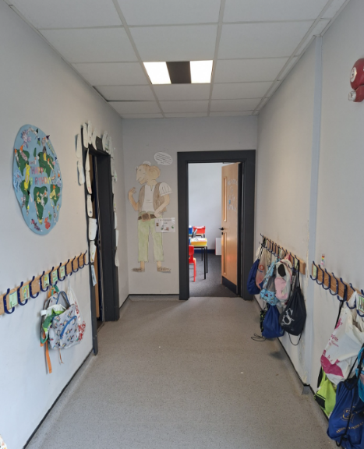
You will use these pegs to hang your belongings on and your peg labels you have designed will show you which one is yours!
The toilets are located at the end of the corridor in this picture and lots of you were able to locate this during our transition morning. We will revisit this in September.

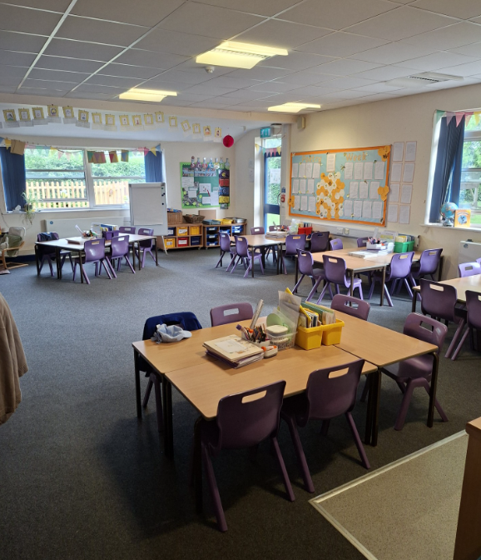
Our Classroom Here is a picture of your new classroom so you can see what to expect in September.
We have a lovely reading area for you to enjoy lot of new books this year!
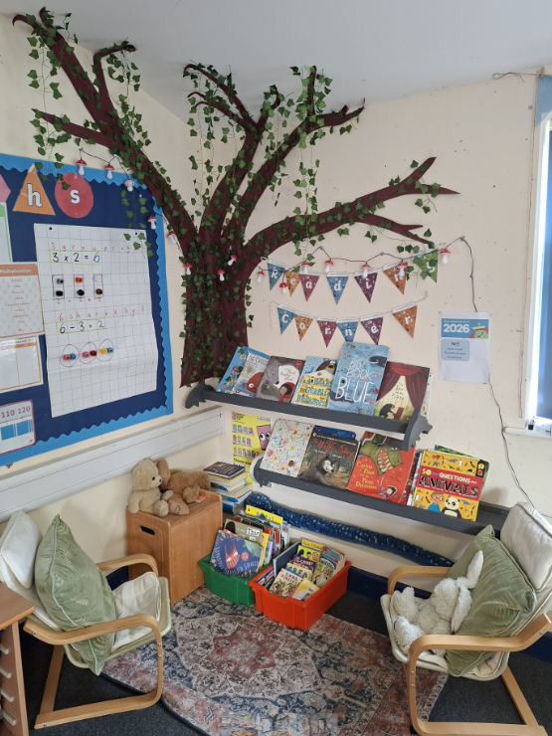


It is going to be a very exciting year in Year 2. Don’t forget to complete the Summer Reading Challenge. I look forward to seeing all the wonderful books you have read.
We hope you have a fantastic summer and I can’t wait to hear all about it when we start Year 2 in September!

As mentioned in our online parent meeting, here are the spelling words which the children should know by the end of Year 2. If you would like to start practising some of them now then that would be amazing.

EYFS | Read |  |  | Write |  |  | EYFS | Read |  |  | Write |  |  | EYFS/*Year 1 | Read |  |  | Write
is |  |  |  |  |  |  | was |  |  |  |  |  |  | when
I |  |  |  |  |  |  | you |  |  |  |  |  |  | what
the |  |  |  |  |  |  | they |  |  |  |  |  |  | one
put |  |  |  |  |  |  | my |  |  |  |  |  |  | out
pull |  |  |  |  |  |  | by |  |  |  |  |  |  | today
full |  |  |  |  |  |  | all |  |  |  |  |  |  | *their
as |  |  |  |  |  |  | are |  |  |  |  |  |  | people
and |  |  |  |  |  |  | sure |  |  |  |  |  |  | oh
has |  |  |  |  |  |  | pure |  |  |  |  |  |  | your
his |  |  |  |  |  |  | said |  |  |  |  |  |  | Mr
her |  |  |  |  |  |  | so |  |  |  |  |  |  | Mrs
go |  |  |  |  |  |  | have |  |  |  |  |  |  | Ms
no |  |  |  |  |  |  | like |  |  |  |  |  |  | ask
to |  |  |  |  |  |  | some |  |  |  |  |  |  | could
into |  |  |  |  |  |  | come |  |  |  |  |  |  | would
she |  |  |  |  |  |  | love |  |  |  |  |  |  | should
push |  |  |  |  |  |  | do |  |  |  |  |  |  | our
he |  |  |  |  |  |  | were |  |  |  |  |  |  | house
of |  |  |  |  |  |  | here |  |  |  |  |  |  | mouse
we |  |  |  |  |  |  | little |  |  |  |  |  |  | water
me |  |  |  |  |  |  | says |  |  |  |  |  |  | want
be |  |  |  |  |  |  | there |  |  |  |  |  |  | any

Year 1 | Read |  |  | Write |  |  | Year 1 /*Year 2 | Read |  |  | Write |  |  | Year 2 | Read |  |  | Write
many |  |  |  |  |  |  | improve |  |  |  |  |  |  | every
again |  |  |  |  |  |  | parents |  |  |  |  |  |  | everybody
who |  |  |  |  |  |  | shoe |  |  |  |  |  |  | even
whole |  |  |  |  |  |  | *door |  |  |  |  |  |  | great
where |  |  |  |  |  |  | floor |  |  |  |  |  |  | break
two |  |  |  |  |  |  | poor |  |  |  |  |  |  | steak
school |  |  |  |  |  |  | find |  |  |  |  |  |  | after
call |  |  |  |  |  |  | kind |  |  |  |  |  |  | fast
different |  |  |  |  |  |  | mind |  |  |  |  |  |  | last
thought |  |  |  |  |  |  | behind |  |  |  |  |  |  | past
through |  |  |  |  |  |  | child |  |  |  |  |  |  | father
friend |  |  |  |  |  |  | children |  |  |  |  |  |  | class
work |  |  |  |  |  |  | wild |  |  |  |  |  |  | grass
once |  |  |  |  |  |  | climb |  |  |  |  |  |  | pass
laugh |  |  |  |  |  |  | most |  |  |  |  |  |  | plant
because |  |  |  |  |  |  | only |  |  |  |  |  |  | path
eye |  |  |  |  |  |  | both |  |  |  |  |  |  | bath
busy |  |  |  |  |  |  | old |  |  |  |  |  |  | sugar
beautiful |  |  |  |  |  |  | cold |  |  |  |  |  |  | half
pretty |  |  |  |  |  |  | gold |  |  |  |  |  |  | money
hour |  |  |  |  |  |  | told |  |  |  |  |  |  | Christmas
move |  |  |  |  |  |  | hold |  |  |  |  |  |  | clothes

